**LIS 161 - Madriaga, Ison**

**File Name: "App.py"**

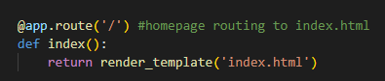

* **code that references the html file index.html. This would be the code block that handles the homepage.**

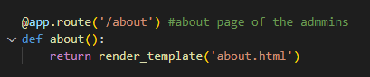

* **code that references the html file about.html. This would be the code block that handles a way to access some information about the people behind the website.**

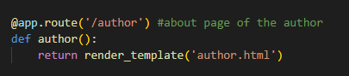

* **code that references the html file author.html. This would be the code block that directs the users to a small biography about the author of SnK.**

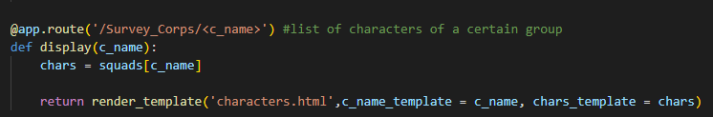

* **code that references the html file characters.html. This also shows how data is being parsed and accepted by the python file. It indicates which data will be shown. This is for the initial array.**

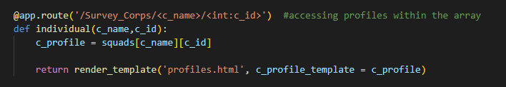

* **code that references the html file profiles.html. This shows how the code is further parsed within an html file.**

**File Name: "index.html"**

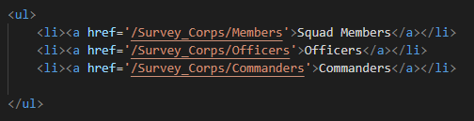

* **list within the homepage that hosts links to other parts of the website. These go to the different small directories.**

**File Name: "Profile.html"**

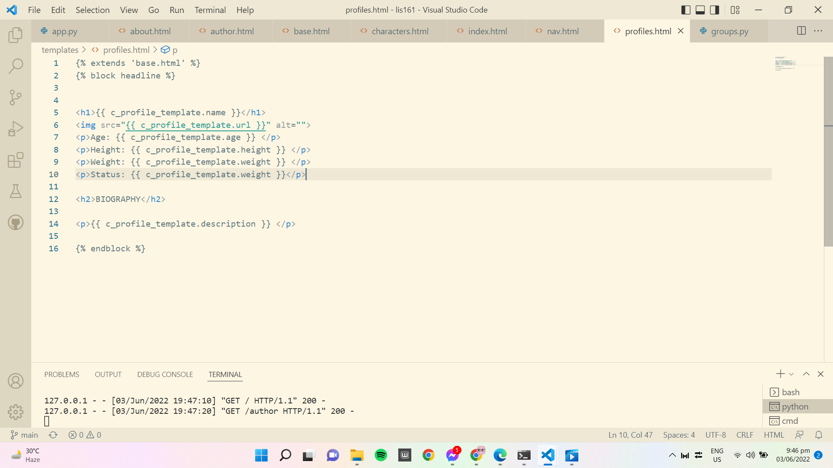

* **This code explains how the website gets the information from groups.py. By clicking the name, it will start to show information about the characters inside the groups.py.**

**File Name: "base.html"**

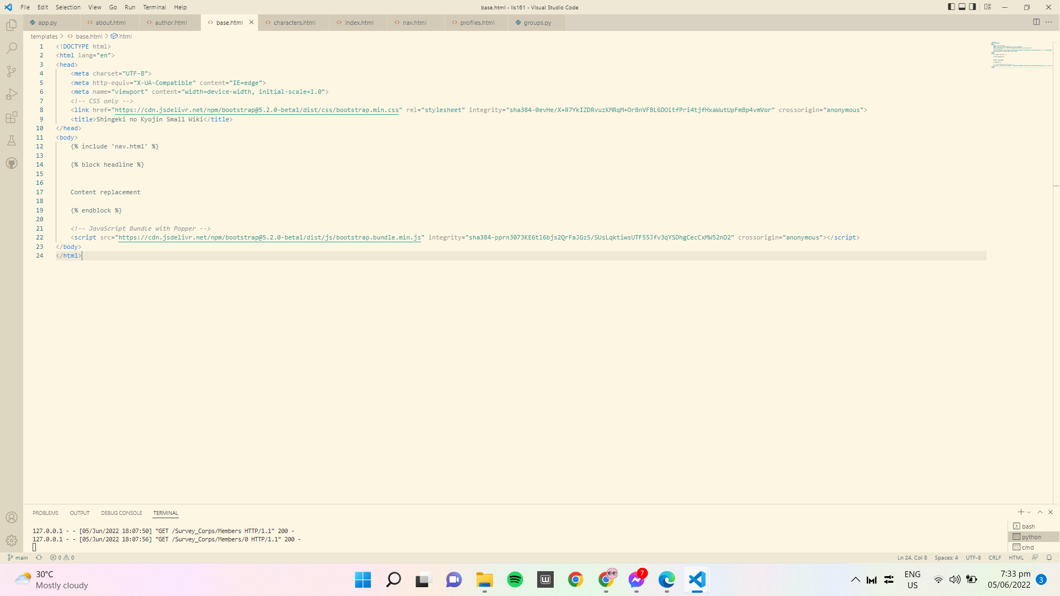



* **It serves as the homepage of the website. It takes CSS/Javascript code src from bootstrap.**

**File Name: "Characters.html"**

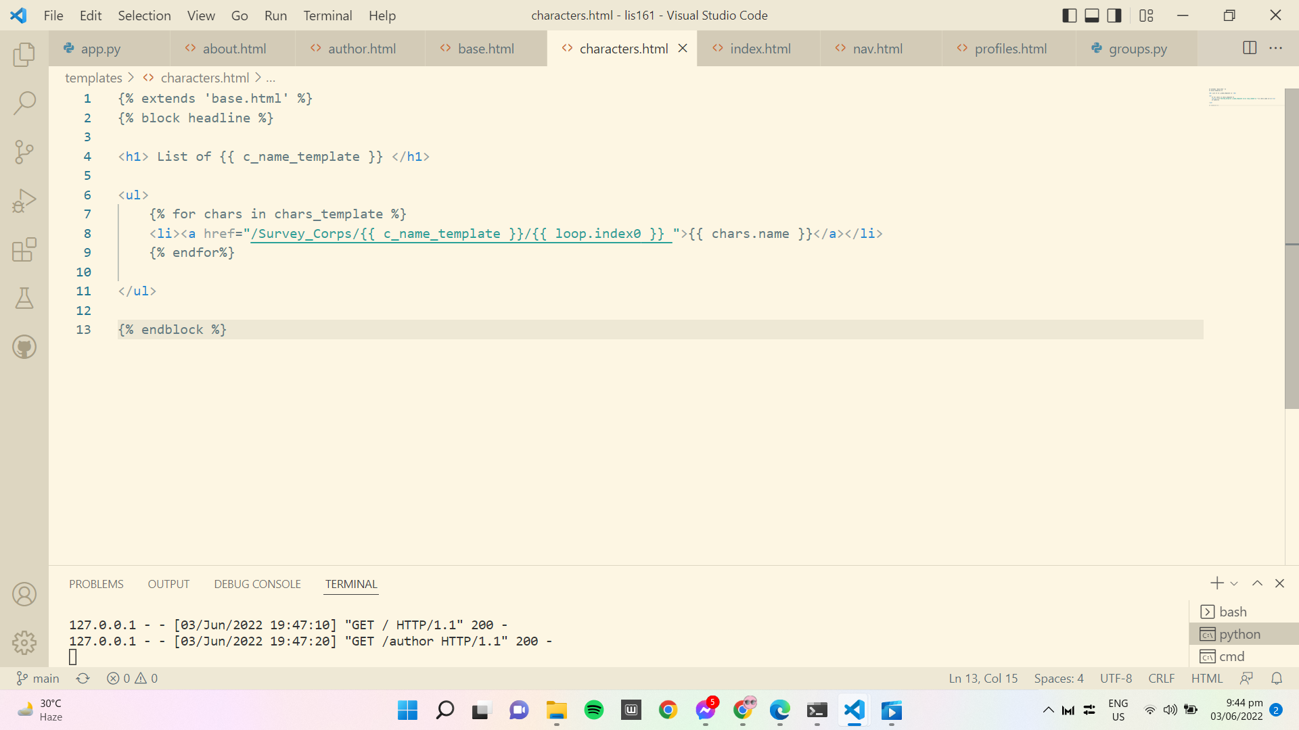

* **It serves as the navigation to the list of characters. This also shows how the website name is being processed.**

**File Name: “Nav.html”**

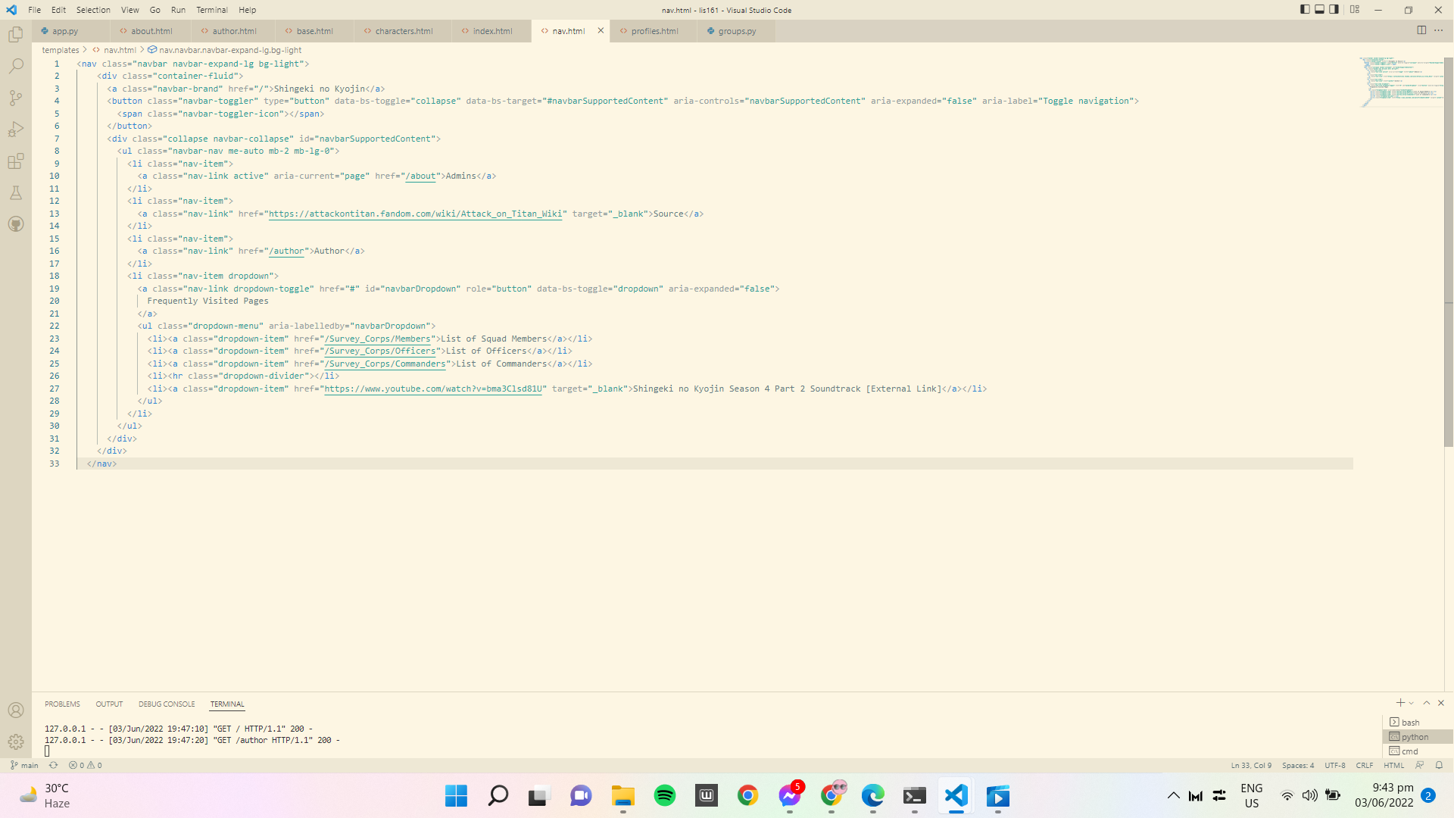

* **The purpose of this code is to navigate the audience throughout the website. It serves as a navigation bar at the top part of the screen, which hosts certain ways to navigate around the website.**

**File Name: “About.html”**

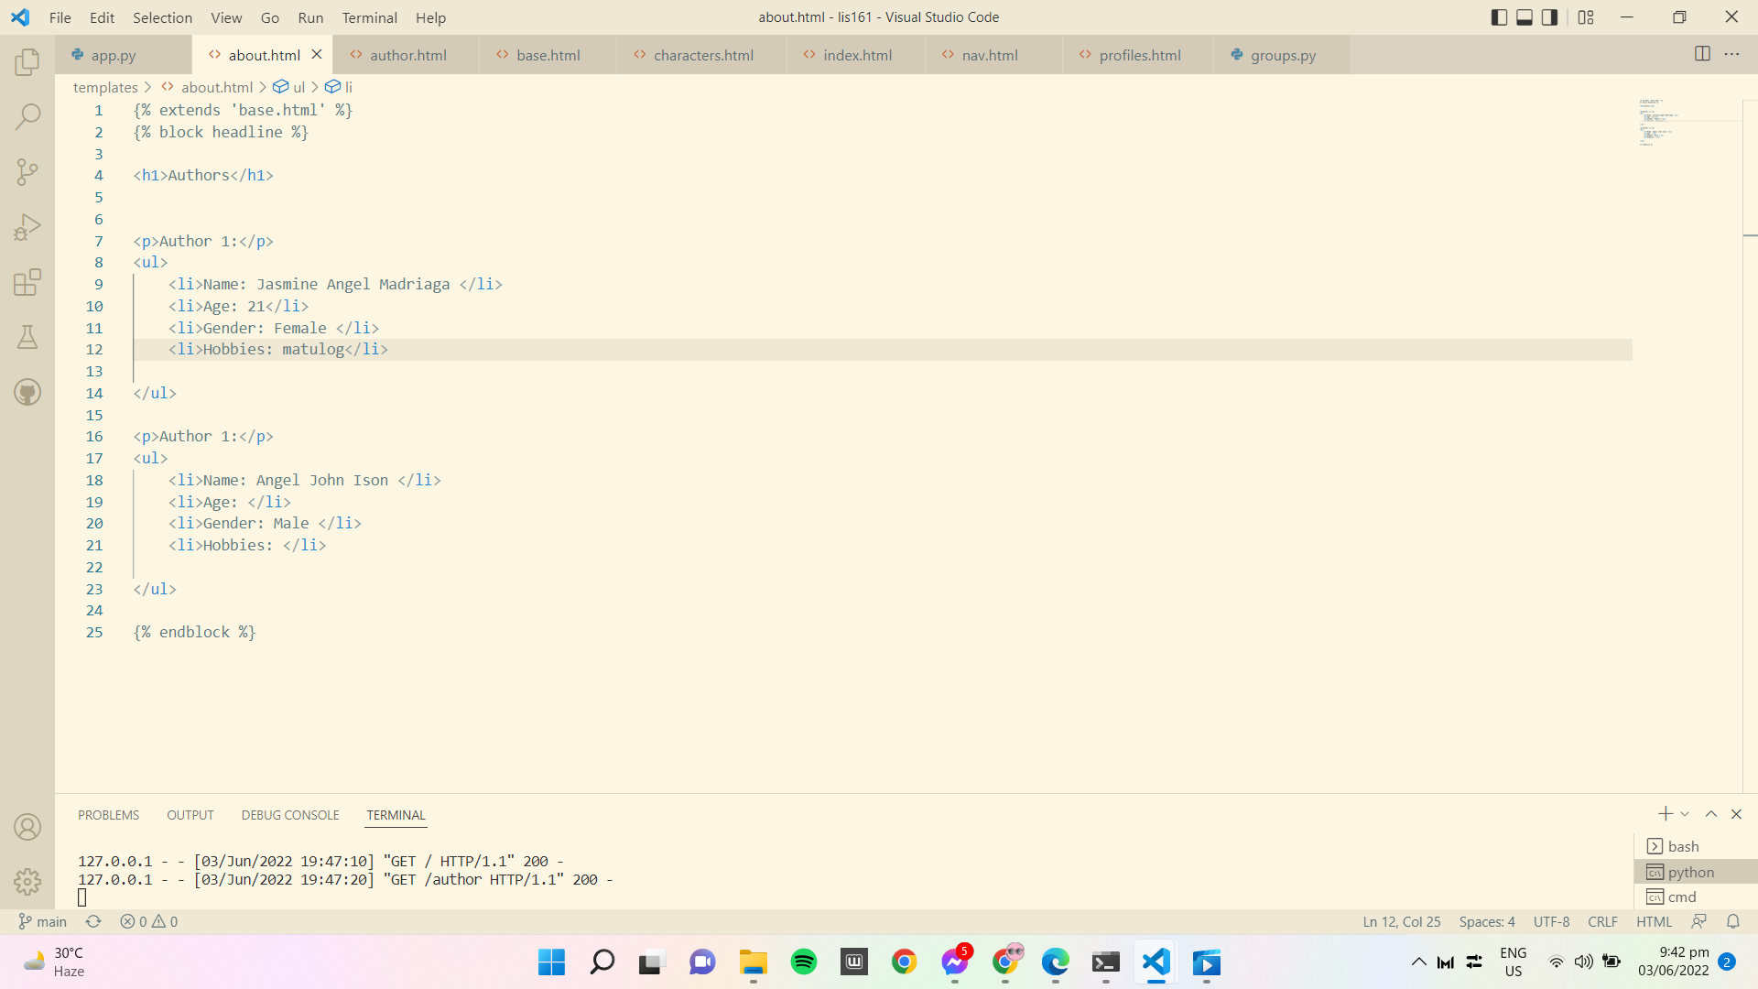

* **The purpose of this code is to show the people behind this project.**

**File Name: "Author.html"**

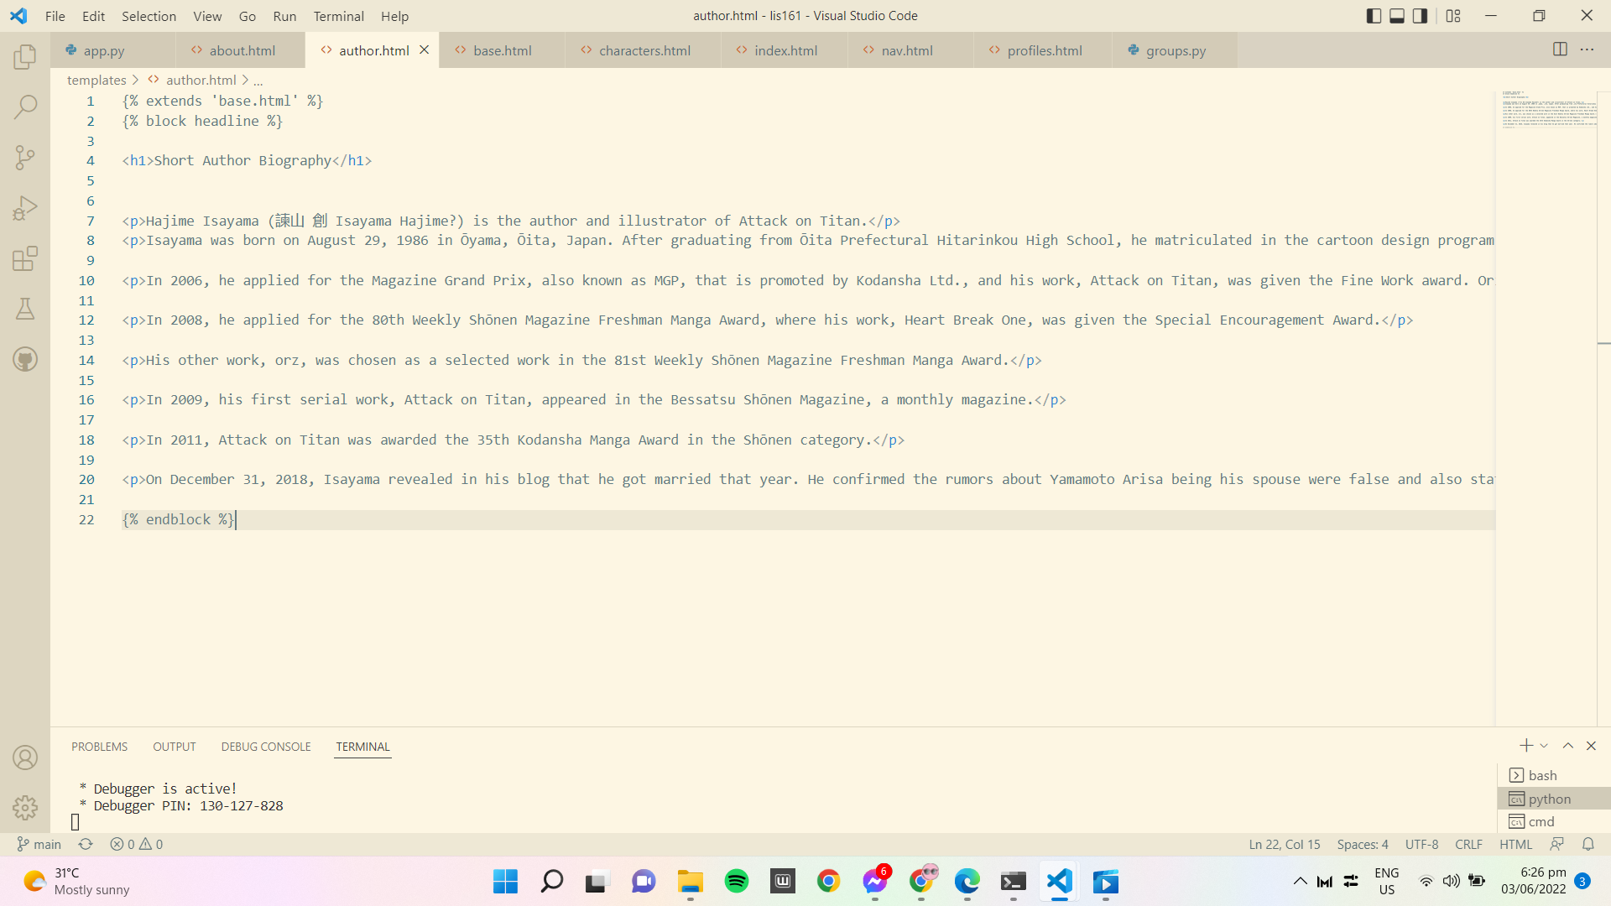

* **The purpose of this HTML file is just a short biography of the author of SnK.**

**File Name: “groups.py”**

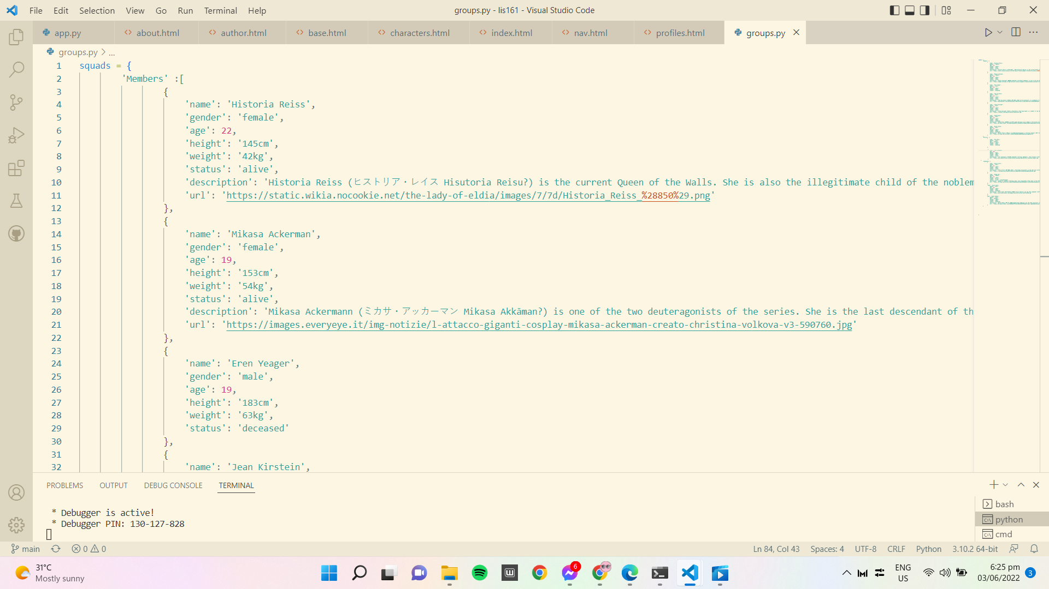

* **Just like in the profile.html, this is where the profile.html gets information. This is the array where the data is extracted from and displayed to the audience.**

Overall, the code is designed to serve as a small wiki fanpage for the anime/manga Shingeki no Kyojin. It’s a framework that can be worked upon to help track down one’s favorite characters within the series.